# Title: Byebuggers Sprint 1

**Sprint Planning snapshots**

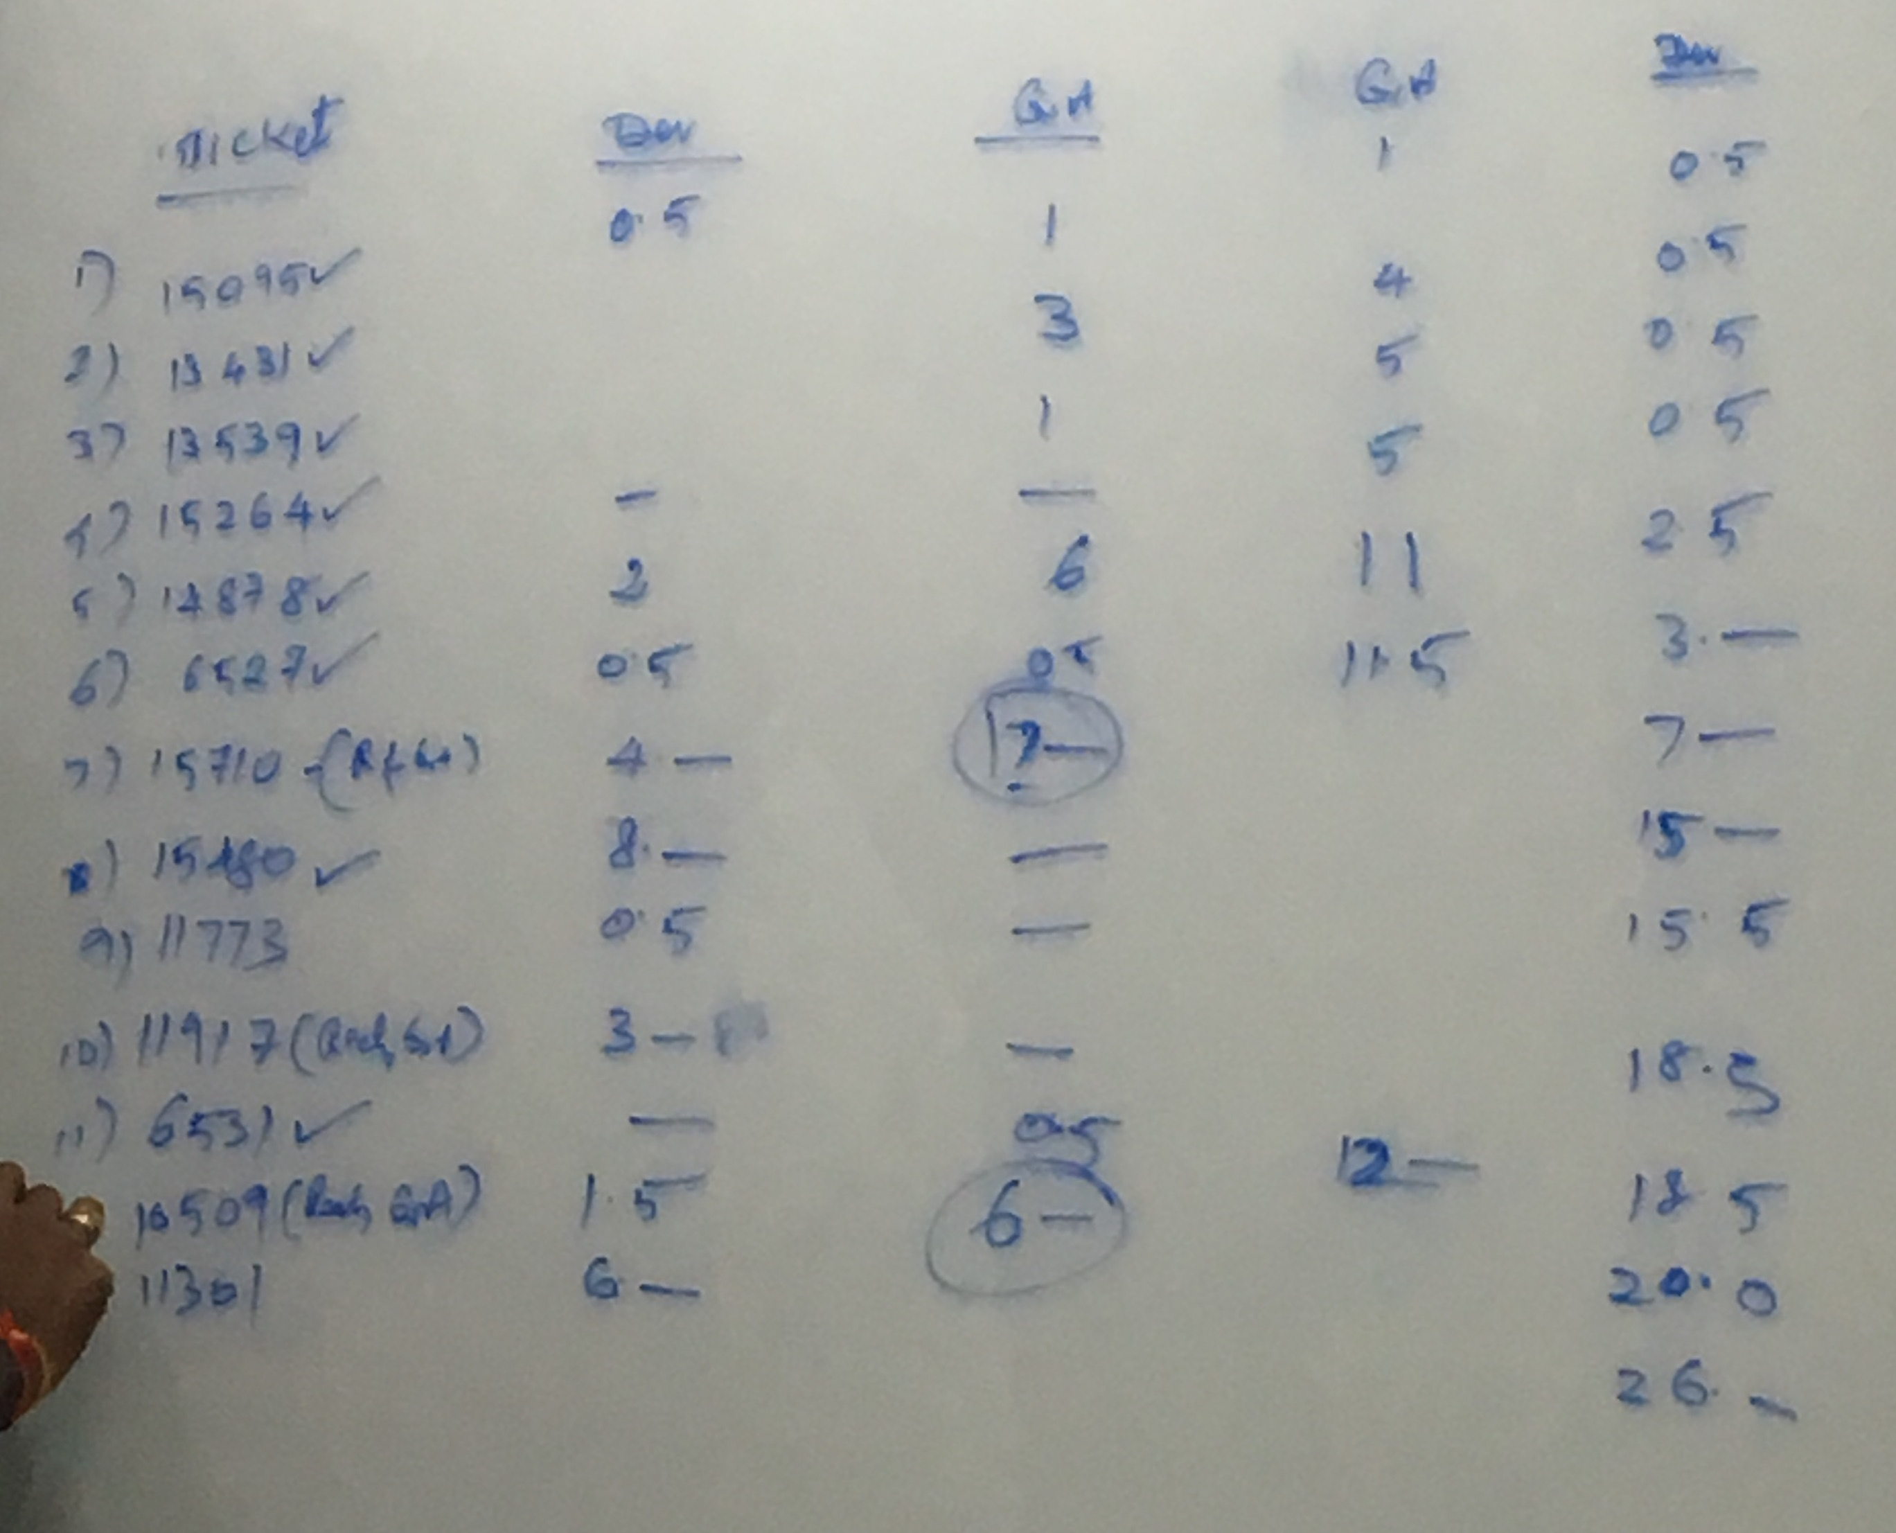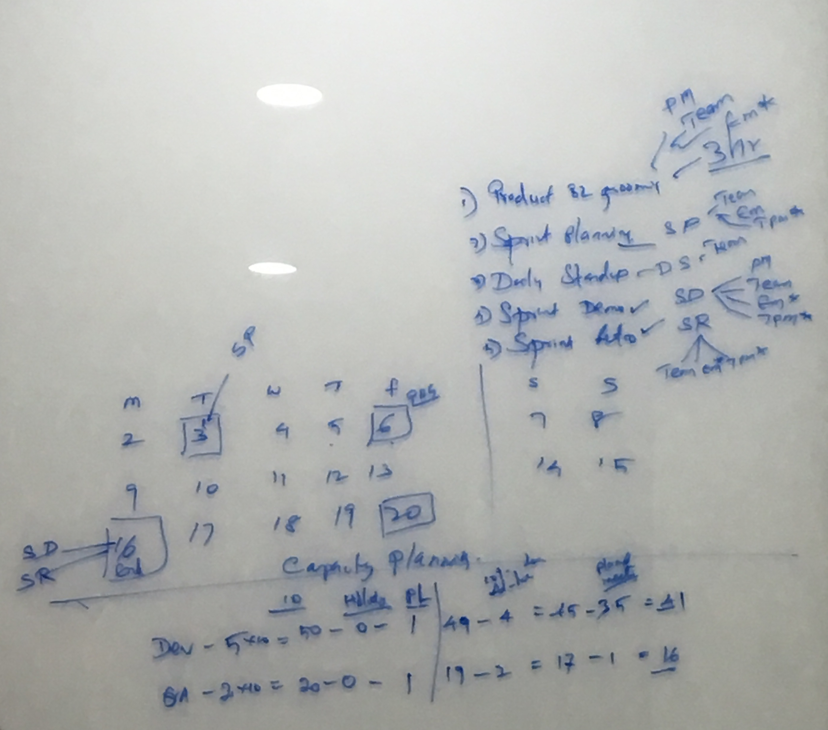

**MOM on Daily Stand ups**

|  |  |
| --- | --- |
| Week 1 | Week 2 |
| MOM on Daily Stand up - Day 1  Adoc Leave : 1 (Teja) Logesh : FSALES -13431 (RTS) Mudhabir : FSALES - 10509 & 150095 Athish : 150095 & support ticket Ajeet : FSALES - 11301 Shivani : FSALES - 11917 Kathir : FSALES - 15710 Dependencies: FSALES-15305(Anish should fix this) | MOM on Daily Stand up - Day 6  Teja : FSALES - 14878 ( iteration bugs + 16087 L4 bug) Logesh : FSALES -14878 ( branch testing) Mudhabir : FSALES-15855(security bug) Athish :  Sales Account Merge(FSALES-10509) Ajeet : FSALES - 11301 (Frontend cases) Shivani : Rspec Kathir : Rspec + review comments  Cumulative Adoc Leaves : 2 Cumulative Adoc Items : 4 Cumulative Completed Tickets : 15095,15914,15999,15982 Dependencies: FSALES-15305(in code review) |
| MOM on Daily Stand up - Day 2  Teja : FSALES - 14878 Logesh : FSALES -13431 (RTS) Mudhabir : FSALES - 10509 Athish : FSALES - 15914 (Ad hoc) Ajeet : FSALES - 11301 Shivani : FSALES - 11917 Kathir : FSALES - 15710 + Security bugs possibilities  Cumulative Ad hoc Leaves : 1 Cumulative Ad hoc items : 1 Cumulative Completed Tickets : 15095 Dependencies: FSALES-15305(Design team will confirm with swati) | MOM on Daily Stand up - Day 7  Teja : FSALES - 14878 ( iteration bugs + 16087 L4 bug) Logesh : FSALES -14878 ( branch testing) Mudhabir : FSALES-15193 Athish :  Sales Account Merge(FSALES-10509) Ajeet : FSALES - 11301 (Review today) Shivani : Review on Freddy calendar+15463 Kathir : Rspec  Cumulative Adoc Leaves : 2 Cumulative Adoc Items : 4 Cumulative Completed Tickets : 15095,15914,15999,15982 Dependencies: FSALES-15305(in code review) |
| MOM on Daily Stand up - Day 3  Teja : FSALES - 14878 Logesh : FSALES -13431 (RTS) Mudhabir : FSALES - 10509 (Rspec failures) Athish : FSALES 6531 & 6521 Ajeet : FSALES - 11301 Shivani : FSALES - 11917 Kathir : FSALES - 15710 + 15914  Cumulative Adoc Leaves : 1 Cumulative Adoc Items : 1 Cumulative Completed Tickets : 15095,15914 Dependencies: FSALES-15305(Design team will confirm with swati) | MOM on Daily Stand up - Day 8  Teja : FSALES - 14878 ( iteration bugs + 16087 L4 bug) Logesh : FSALES -14878 ( branch testing) Mudhabir : Race condition security bug Athish :  Sales Account Merge(FSALES-10509) Ajeet : FSALES - 11301 + Role Userstory Shivani : Rspec Kathir : Rspec  Cumulative Adoc Leaves : 2 Cumulative Adoc Items : 4 Cumulative Completed Tickets : 15095,15914,15999,15982 Dependencies: FSALES-15305(in code review) |
| MOM on Daily Stand up - Day 4  Teja : FSALES - 14878 (review comments) Logesh : FSALES -13431 (RTS dependency) + 15999(bug) Mudhabir : Rspec + 15999(bug) Athish : Ad hoc Leave Ajeet : Rspec Shivani : FSALES - 11917 (review) + Rspec Kathir : Rspec + Security bugs possibilities  Cumulative Adoc Leaves : 2 Cumulative Adoc Items : 2 Cumulative Completed Tickets : 15095,15914 Dependencies: FSALES-15305(Design team will confirm with swati) | MOM on Daily Stand up - Day 9 |
| MOM on Daily Stand up - Day 5  Teja : FSALES - 14878 (review comments) Logesh : FSALES -14878  Mudhabir : Rspec Athish : Notes + Sales Account Merge Ajeet : Rspec Shivani : Rspec Kathir : 15982+Rspec + Security bugs possibilities  Cumulative Adoc Leaves : 2 Cumulative Adoc Items : 3 Cumulative Completed Tickets : 15095,15914,15999,15982 Dependencies: FSALES-15305(Anish works on this ticket) | MOM on Daily Stand up - Day 10 |

To view our sprint Retrospect [click here](https://confluence.freshworks.com/pages/viewpage.action?pageId=230085053)